Evening Lenten Meditation
Lent 2020 Week of March 25th

Holy God, holy and mighty, holy and immortal, have mercy on us.

OPENING HYMN

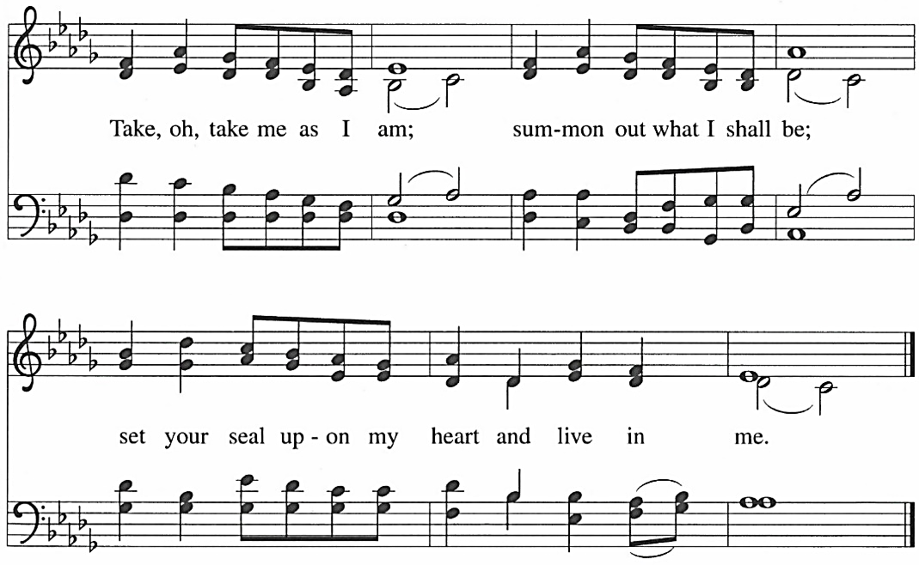

APOSTLES’ CREED
I believe in God,
the Father almighty, creator of heaven and earth.
I believe in Jesus Christ,
God’s only Son, our Lord,
who was conceived by the Holy Spirit,
born of the virgin Mary,
suffered under Pontius Pilate,
was crucified, died, and was buried;
he descended to the dead.
On the third day he rose again;
he ascended into heaven,
he is seated at the right hand of the Father,
and he will come to judge the living and the dead.
I believe in the Holy Spirit,
the holy catholic church,
the communion of saints,
the forgiveness of sins,
the resurrection of the body,
and the life everlasting.
Amen.

LORD’S PRAYER
Our Father in heaven, hallowed be your name,
your kingdom come, your will be done, on earth as in heaven.
Give us today our daily bread.
Forgive us our sins as we forgive those who sin against us.
Save us from the time of trial and deliver us from evil.
For the kingdom, the power, and the glory are yours, now and forever. Amen.

REFLECTION Pastor Jane

EVENING PRAYER
We give thanks to you, heavenly Father, through Jesus Christ your dear Son, that you have graciously protected us today. We ask you to forgive us all our sins, where we have done wrong, and graciously to protect us tonight. Into your hands we commend ourselves: our bodies, our souls, and all that is ours. Let your holy angels be with us, so that the wicked foe may have no power over us. Amen.

CLOSING HYMN

