Evening Lenten Meditation
Lent 2020 Week of March 18th

Holy God, holy and mighty, holy and immortal, have mercy on us.
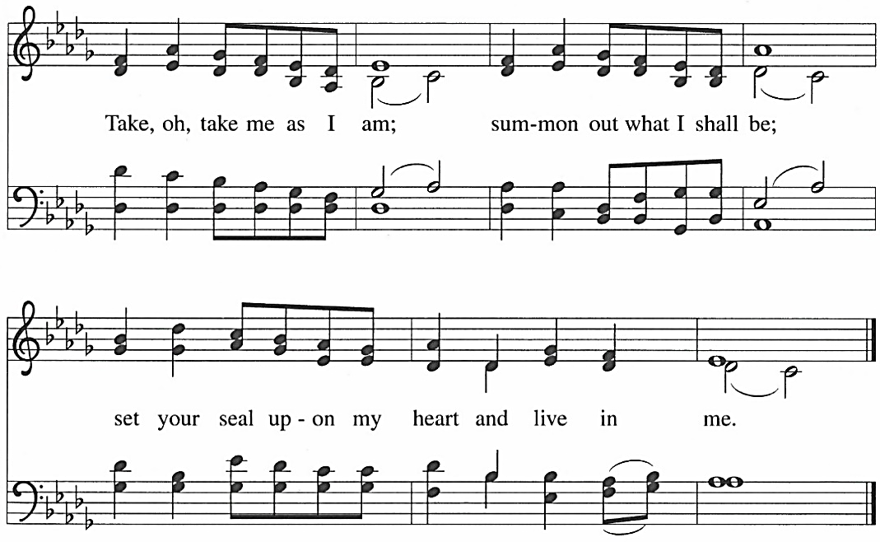
OPENING HYMN

APOSTLES’ CREED
I believe in God, the Father almighty, creator of heaven and earth.
I believe in Jesus Christ, God’s only Son, our Lord,
who was conceived by the Holy Spirit, born of the virgin Mary,
suffered under Pontius Pilate, was crucified, died, and was buried;
he descended to the dead.
On the third day he rose again; he ascended into heaven,
he is seated at the right hand of the Father,
and he will come to judge the living and the dead.
I believe in the Holy Spirit, the holy catholic church,
the communion of saints, the forgiveness of sins,
the resurrection of the body, and the life everlasting. Amen.

LORD’S PRAYER
Our Father in heaven, hallowed be your name,
your kingdom come, your will be done, on earth as in heaven.
Give us today our daily bread.
Forgive us our sins as we forgive those who sin against us.
Save us from the time of trial and deliver us from evil.
For the kingdom, the power, and the glory are yours, now and forever. Amen.

REFLECTION
For our Wednesdays in Lent this year we have chosen to use Responsive Prayer with a
focus on the Lord’s Prayer and Luther’s teachings on that prayer as found in his Small
Catechism. We began by noting that the prayer begins OUR not my – thereby uniting all who
pray into one family. We looked at the Aramaic meaning of “Father” and learned it means
Abba/Poppa – thereby connecting us with God who claims us as God’s children, God’s family.
We examined that word “holy” and remembered the holiness of our God and that as we are
baptized into God’s family, we, too, are called to reflect God’s holiness in all that we do. Last
week we focused on the second and third petitions learning that in those petitions we pray for
God’s kingdom to come now – not just at the end of time – and that by doing God’s will now
we, by the power of the Holy Spirit, help bring that kingdom to all the earth now.

This evening we focus on the fourth petition: Give us today our daily bread. Luther writes: WHAT DOES THIS MEAN? In fact, God gives daily bread without our prayer, even to all
evil people, but we ask this prayer that God cause us to recognize what our daily bread is and to
receive it with thanksgiving. WHAT THEN DOES “DAILY BREAD” MEAN? Everything included in
the necessities and nourishment for our bodies, such as food, drink, clothing, shoes, house, farm,
fields, livestock, money, property, an upright spouse, upright children, upright members of the
household, upright and faithful rulers, good government, good weather, peace, health, decency,
honor, good friends, faithful neighbors and the like.
There is much there in Luther’s words for us to ponder. For example, do we always
remember that even these basic necessities of life are gifts from our gracious God? Do we
remember to be good neighbors, good citizens, good parents, good children? Do we remember
to live that ”holy” in all are interactions with one another?
But for this day, I’d like to share with you one of the teachings about this petition in the
Lord’s Prayer that our confirmation youth learn at Faith Alive. They learn there is a vast
difference between praying for my wants and praying for my needs. When I pray that my
“wants” be met at the expense of my taking from the needs of others, I am not praying this
prayer as Jesus taught us to pray. I can’t help but think about our current grocery store
situation. Out of fear, out of wanting rather than needing, shelves are empty and some cannot
even purchase the basic needs for their family. Think about that. Let’s pray.
Gracious and Loving God, you are always so much more ready to hear than we are to pray.
You are so much more ready to forgive than we are to confess our human sin – our grasping and
taking what we want without a thought for the needs of others. We do now ask for forgiveness,
for a change of heart, so that may have what they need in this time of crisis. We ask this in the
name of Jesus, Your Son, our Lord and Savior. Amen.

EVENING PRAYER
We give thanks to you, heavenly Father, through Jesus Christ your dear Son, that you have graciously protected us today. We ask you to forgive us all our sins, where we have done wrong, and graciously to protect us tonight. Into your hands we commend ourselves: our bodies, our souls, and all that is ours. Let your holy angels be with us, so that the wicked foe may have no power over us. Amen.
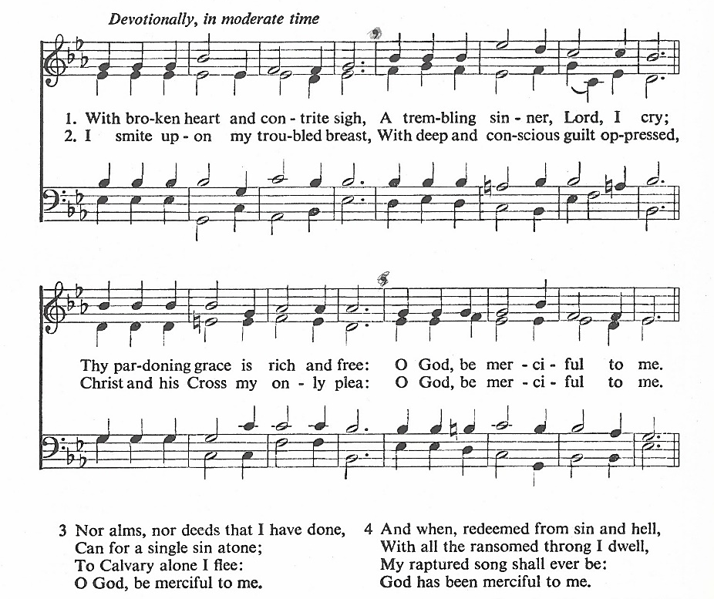
CLOSING HYMN

