Incarnation Lutheran Church
Resurrection of our Lord
Online Worship
April 12, 2020

GATHERING
PRELUDE Ciacona with Variations in D major Johann Pachelbel

PROCLAMATION OF EASTER
P: Alleluia, Christ is Risen!
C: Christ is risen, indeed. Alleluia

GATHERING HYMN Jesus Christ Is Risen Today ELW 365
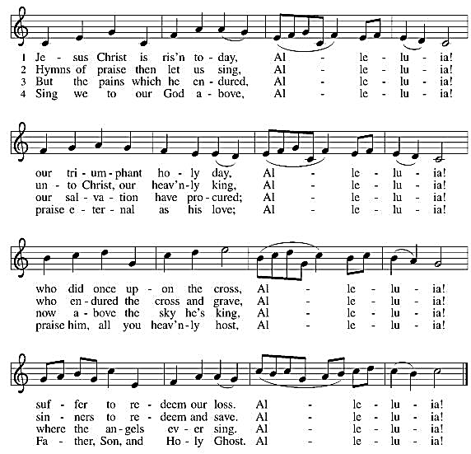

Greeting
P: The grace of our Lord, Jesus Christ, the love of God and the communion of the Holy Spirit be with you all. And also with you.

PRAYER OF THE DAY
God of mercy, we no longer look for Jesus among the dead, for he is alive and has become the Lord of life. Increase in our minds and hearts the risen life we share with Christ, and help us to grow as your people toward the fullness of eternal life with you, through Jesus Christ, our Savior and Lord, who lives and reigns with you and the Holy Spirit, one God, now and forever. Amen.

WORD

FIRST READING: Jeremiah 31:1-6
¹At that time, says the Lord, I will be the God of all the families of Israel, and they shall be my people.
²Thus says the Lord:
The people who survived the sword
found grace in the wilderness;
when Israel sought for rest,
³the Lord appeared to him from far away.
I have loved you with an everlasting love;
therefore I have continued my faithfulness to you.
⁴Again I will build you, and you shall be built,
O virgin Israel!
Again you shall take your tambourines,
and go forth in the dance of the merrymakers.
⁵Again you shall plant vineyards
on the mountains of Samaria;
the planters shall plant,
and shall enjoy the fruit.
⁶For there shall be a day when sentinels will call
in the hill country of Ephraim:
“Come, let us go up to Zion,
to the Lord our God.”
The Word of the Lord. Thanks be to God.

PSALM Psalm 118: 1-2, 14-24
¹Give thanks to the Lord, for the | Lord is good;
God’s mercy en- | dures forever.
²Let Israel | now declare,
“God’s mercy en- | dures forever.”
¹⁴The Lord is my strength | and my song,
and has become | my salvation.
¹⁵Shouts of rejoicing and salvation echo in the tents | of the righteous:
“The right hand of the | Lord acts valiantly!
¹⁶The right hand of the Lord| is exalted!
The right hand of the | Lord acts valiantly!”
¹⁷I shall not | die, but live,
and declare the works | of the Lord.
¹⁸The Lord indeed pun- | ished me sorely,
but did not hand me o- | ver to death.
¹⁹Open for me the | gates of righteousness;
I will enter them and give thanks | to the Lord.
²⁰“This is the gate | of the Lord;
here the righ- | teous may enter.”
²¹I give thanks to you, for you have | answered me
and you have become | my salvation.
²²The stone that the build- | ers rejected
has become the chief | cornerstone.
²³By the Lord has | this been done;
it is marvelous | in our eyes.
²⁴This is the day that the | Lord has made;
let us rejoice and be | glad in it.

SECOND READING: Acts 10:34-43

³⁴Peter began to speak to [the people]: “I truly understand that God shows no partiality, ³⁵but in every nation anyone who fears him and does what is right is acceptable to him. ³⁶You know the message he sent to the people of Israel, preaching peace by Jesus Christ—he is Lord of all. ³⁷That message spread throughout Judea, beginning in Galilee after the baptism that John announced: ³⁸how God anointed Jesus of Nazareth with the Holy Spirit and with power; how he went about doing good and healing all who were oppressed by the devil, for God was with him. ³⁹We are witnesses to all that he did both in Judea and in Jerusalem. They put him to death by hanging him on a tree; ⁴⁰but God raised him on the third day and allowed him to appear, ⁴¹not to all the people but to us who were chosen by God as witnesses, and who ate and drank with him after he rose from the dead. ⁴²He commanded us to preach to the people and to testify that he is the one ordained by God as judge of the living and the dead. ⁴³All the prophets testify about him that everyone who believes in him receives forgiveness of sins through his name.”
The Word of the Lord. Thanks be to God.

GOSPEL ACCLAMATION
GOSPEL READING: John 20:1-18

The Holy Gospel according to John. Glory to you, O Lord.

¹Early on the first day of the week, while it was still dark, Mary Magdalene came to the tomb and saw that the stone had been removed from the tomb. ²So she ran and went to Simon Peter and the other disciple, the one whom Jesus loved, and said to them, “They have taken the Lord out of the tomb, and we do not know where they have laid him.” ³Then Peter and the other disciple set out and went toward the tomb. ⁴The two were running together, but the other disciple outran Peter and reached the tomb first. ⁵He bent down to look in and saw the linen wrappings lying there, but he did not go in. ⁶Then Simon Peter came, following him, and went into the tomb. He saw the linen wrappings lying there, ⁷and the cloth that had been on Jesus’ head, not lying with the linen wrappings but rolled up in a place by itself. ⁸Then the other disciple, who reached the tomb first, also went in, and he saw and believed; ⁹for as yet they did not understand the scripture, that he must rise from the dead. ¹⁰Then the disciples returned to their homes.
¹¹But Mary stood weeping outside the tomb. As she wept, she bent over to look into the tomb; ¹²and she saw two angels in white, sitting where the body of Jesus had been lying, one at the head and the other at the feet. ¹³They said to her, “Woman, why are you weeping?” She said to them, “They have taken away my Lord, and I do not know where they have laid him.” ¹⁴When she had said this, she turned around and saw Jesus standing there, but she did not know that it was Jesus. ¹⁵Jesus said to her, “Woman, why are you weeping? Whom are you looking for?” Supposing him to be the gardener, she said to him, “Sir, if you have carried him away, tell me where you have laid him, and I will take him away.” ¹⁶Jesus said to her, “Mary!” She turned and said to him in Hebrew, “Rabbouni!” (which means Teacher). ¹⁷Jesus said to her, “Do not hold on to me, because I have not yet ascended to the Father. But go to my brothers and say to them, ‘I am ascending to my Father and your Father, to my God and your God.’ ” ¹⁸Mary Magdalene went and announced to the disciples, “I have seen the Lord”; and she told them that he had said these things to her.
The Gospel of the Lord. Praise to you, O Christ.

SERMON Pastor Jane

HYMN OF THE DAY Day of Arising ELW 374
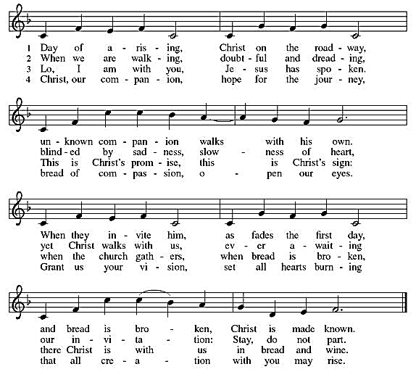

NICENE CREED
Let us profess our faith using the word of the Nicene Creed.

We believe in one God,
the Father, the Almighty,
maker of heaven and earth,
of all that is, seen and unseen.
We believe in one Lord, Jesus Christ,
the only Son of God,
eternally begotten of the Father,
God from God, Light from Light,
true God from true God,
begotten, not made,
of one Being with the Father;
through him all things were made.
For us and for our salvation
he came down from heaven,
was incarnate of the Holy Spirit and the virgin Mary
and became truly human.
For our sake he was crucified under Pontius Pilate;
he suffered death and was buried.
On the third day he rose again
in accordance with the scriptures;
he ascended into heaven
and is seated at the right hand of the Father.
He will come again in glory to judge the living and the dead,
and his kingdom will have no end.
We believe in the Holy Spirit, the Lord, the giver of life,
who proceeds from the Father and the Son,
who with the Father and the Son is worshiped and glorified,
who has spoken through the prophets.
We believe in one holy catholic and apostolic church.
We acknowledge one baptism for the forgiveness of sins.
We look for the resurrection of the dead,
and the life of the world to come. Amen.

PRAYERS OF INTERCESSION

Uplifted by the promised hope of healing and resurrection, we join the people of God in all times and places in praying for the church, the world, and all who are in need.
A brief silence.
God of resurrection, from the very beginning you give the church the gift of women as your witnesses: as preachers, teachers, and leaders especially, Pastor Jane, Savannah, Teresa, Amy and all women at Incarnation. Open our ears to their proclamation this day and always. Lord, in your mercy, hear our prayer.

All your creation praises you—the earth hums, the seas pulse, the stars shine, and the galaxies whirl in glorious harmonies to honor you. Let us hear and blend our voices in the song. Lord, in your mercy, hear our prayer.

The countries of the world experience disunity and conflict; we set our minds on fear and greed rather than on your rule of justice and steadfast love. Build up all countries on your cornerstone of peace. Lord, in your mercy, hear our prayer.

We still weep with those who weep, and mourn with those who mourn. Cradle the fearful, the suffering, and the dying, assuring them of your loving presence. Tend to all who cry out for relief especially, Rosemary Kinard, Jenny Gantt, Pete Brooks, Ina Roof Berkey, Don Moody, Charlie, Tom Baldwin, Gayle Faust, Jackie Rhodes, all those that are home bound, and Emily Prince.
Lord, in your mercy, hear our prayer.

Bless the creative and helpful service of worship leaders this day: musicians, worship assistants, preachers, readers, and all others who provide welcome and hospitality in our midst. Lord, in your mercy, hear our prayer.

Inspire, Renew, and Empower those celebrating their baptismal anniversaries this week especially, Fran Sims and Elizabeth Johnson. Lord, in your mercy, hear our prayer.

Give joy to those who celebrate birthdays this week, especially, Jeff Adair and Olivia Jackson. Lord, in your mercy, hear our prayer.

God of mercy, we pray for all suffering from the vicious impact of the Coronavirus. Give strength, comfort, and peace to all who are suffering in any way. We pray especially for the health professionals caring for the sick and dying, especially Jason Harris, Dr. Jordan Shealy, Katelyn Shealy, Melissa Corbett, Maureen Kelly, Sue Hoffmann, Ashley English, and Dr. Duncan Norton. Sustain them in their weariness, strengthen them in their endeavors, and keep them safe from all harm so they might care for those who need the touch of their healing hands. Lord, in your mercy, hear our prayer.

Risen Lord, you went ahead of us into the grave and defeated the powers of evil. We remember those who have died. Inspire us to live our lives in this resurrection hope and draw us to you in our final days. Lord, in your mercy, hear our prayer.

Here other intercessions may be offered.

With bold confidence in your love, almighty God, we place all for whom we pray into your eternal care; through Christ our Lord.
Amen.

THE LORD’S PRAYER
Our Father, who art in heaven,
hallowed be thy name,
thy kingdom come,
thy will be done,
on earth as it is in heaven.
Give us this day our daily bread;
and forgive us our trespasses,
as we forgive those
who trespass against us;
and lead us not into temptation,
but deliver us from evil.
For thine is the kingdom,
and the power, and the glory,
forever and ever. Amen.

BLESSING

May the One who brought forth Jesus from the dead
raise you to new life, fill you with hope,
and turn your mourning into dancing.
Almighty God, Father + Son and Holy Spirit,
Bless you now and forever.
Amen.

DISMISSAL

Go in Peace!
Share the Good News!
Christ is risen! Alleluia! Alleluia!
Thanks be to God! Alleluia! Alleluia!

Announcements!
Easter Lilies given to the Glory of God
In Memory of Ted Fisher………………………………….…………Given by Mimi Fisher
In Memory of Dolly Savitz…….…………………………………….Given by Isaac Savitz
In Memory of Gilbert Leata………………………………………...Given by Ken Gehler
In Memory of Betty James………………………………..……..…Given by Ken Gehler
In Memory of Bill and Stan Gehler…………........................Given by Ken Gehler
In Memory of Glenn and Domenika Brooks….given by Cheryl and John Carroll

In Honor of her Children and Grandchildren….Given by LaVonne Taylor- Shumaker
In Honor of Mark and Mary Karl Boepple……….……Given by Porter and Memi Kinard
In Honor of Amy Kinard……………………………….….…Given by Porter and Memi Kinard
In Honor of our granddaughter, Porter Boepple….…Given by Porter and Memi Kinard
In Honor of Hoover and Nita Kadane………………….….Given by Cheryl and John Carroll

